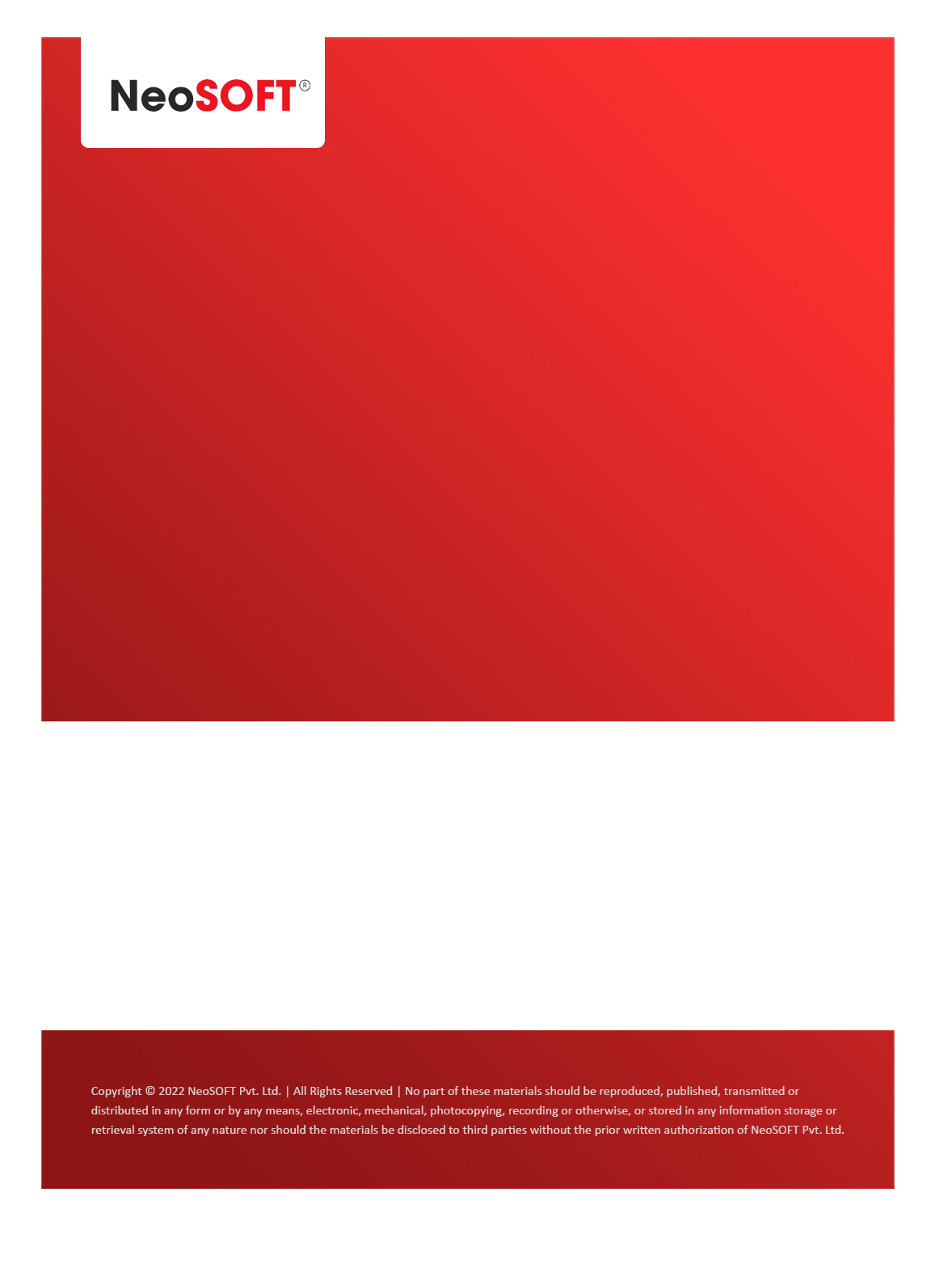`

**Eltizam MOM – Project Status meeting**

Eltizam

Client Name

NeoSOFT is a SEI-CMMI Level-5 Global IT Consulting & Software Solutions Provider

**6th July,** 2023

|  |  |
| --- | --- |
| **Meeting Date, Time, and Attendee Details** | |
| **Date** | 6th July 2023 |
| **Venue** | MS Teams |
| **Time** | 04.00 PM – 04.30 PM IST |
| **Meeting Type** | Project status discussions |
| **Internal Attendees** | * YallaReddy |
| **Client Attendees** | * Karuna Pawar |
| **Presented By** |  |
| **MOM Prepared By** | * YallaReddy |

|  |  |
| --- | --- |
| **Details of Meeting** | |
| **Sr. No.** | **Description** |
| 1 | Discussed current status on Evaluation process modules. |
| 2 | As per discussion, we will start design on master modules once NeoSOFT receives signoff from Eltizam client. |
| 3 | Also, expecting to get new requirement changes from client from next week. |
| 4 |  |
| 5 |  |
| 6 |  |
| 7 |  |

|  |  |  |  |  |  |
| --- | --- | --- | --- | --- | --- |
| **Actionable** | | | | | |
| **Sr. No.** | **Action Item** | **Assigned to** | **Assigned Date** | **Expected Completion Date** | **Status** |
| 1 | We expecting official signoff from Vinod to start design on approved masters modules. | Vinod & team |  |  |  |
| 2 |  |  |  |  |  |
|  |  |  |  |  |  |